Village Status

* Turn:
* Population: 216
* Units: 3 manpower
* Buildings:
  + Crude Shrine
  + Hedge’s Hovel
  + Herbalist’s Workbench
  + Scholar’s Hut
  + Moat
* Resources:
  + Food: 0
  + Wood: 1
* Animals:
  + Wolves: 7
  + ~~Morghouls: 2~~
  + Eagle: 1
* Technology:
  + On Board:
    - Animal Husbandry
    - Currency
  + Implemented:
    - Bowing and Fletching
    - Item Lore
    - Alchemy
    - Leather Working
* Sites:
  + F3 – enclave hex
  + B3 (wood) – enclave hex (Etemnus’ Lair)

***Ongoing Threads***

* Rivka – Learn the burial rituals of the Lantern Gods
  + Ulder done
  + Where is Mordain? DID ANYONE TELL KAREN HOW THAT ALL WENT DOWN?
* Meet the Freemen
* Go talk to the Theyd of Uldranna
* Andrick – Morghouls have been left with Etemnus
* Calistae needs her tools, but that is a journey
* Baby boom in 4 months?
* Map to fire magic site
* Crazy elven oracle in the hills
* What leather goods can be created

***Important People***

* The Council
  + Timon – Elder and leader of the tribe
  + Spiro – Warmaster and brother of Timon
  + Rivka (f) – Priestess of Aquae, Liberator
  + Vaara – Mage and half-blood
  + Lothor – Huntmaster
  + Adele (f) – Head of the builders
  + Etreus – Head scout
* Villagers
  + Wren – Temple assistant
  + Oyun – Beast keeper, chicken farmer
  + Nefele – Spiro’s wife
  + Urige – Farmer leader
  + Grumn – Ashen, experimenter, sidekick
  + Vasilios – Spiro’s son, warrior
* Refugees (freemen)
  + Talik – De Facto leader of the Ansippans
  + Skaro – Hot headed warrior who incited the raiders of Rigut
  + Kelthinda – Mother of Skaro
* Dwarven Wanderers
  + Samson – Needs Calistae’s tools to unlock lock tech to enter locked enclave and recover seed of Mordain
  + Scorpio
  + Shel
* Others
  + Etemnus – Powerful forest spirit
  + The Satyr – Etemnus’ servant
  + Phaedra – Messenger of Aquae
  + Calistae – Shadow witch, mother to Andrik & Vaara

***Kelthinda’s Plea***

* The council has been called to discuss what to do with the raider situation
* Kelthindais there – she gives an impassioned tearful speech about how she knows her son is alive and is a captive of Rigut
  + She cannot rest until she knows everything has been done to retrieve her only child
* Timon thinks caution should be the main consideration (***no***)
* Spiro has been convinced by Vasilios that a team should scout Rigut (***yes***)
* Etreus notes that all he has seen indicates that their warriors are well-trained and drilled. They would be formidable opponents on a battlefield (***no***)
* Lothor does not like the thought of sitting back and being timid (***yes***)
* Adele thinks we are in no position to battle these raiders directly, and should try our best to keep our distance from them (***no***)

***Igni – Song of Fire***

* Far to the north of the enclave lies the resting place of Igni, the scroll that teaches fire magic
* Igni is housed in a small dungeon that lies in an underground chamber, near a volcanic seep
* As the group travels up river, the water will become more and more contaminated with volcanic salts
* The lake itself is fed by dozens of hot springs and steaming streams
* It is relatively easy to find where all of this pours into the lake (navigate), but more searching will need to be done to find the actual entrance into the caves

***Caves of Igni***

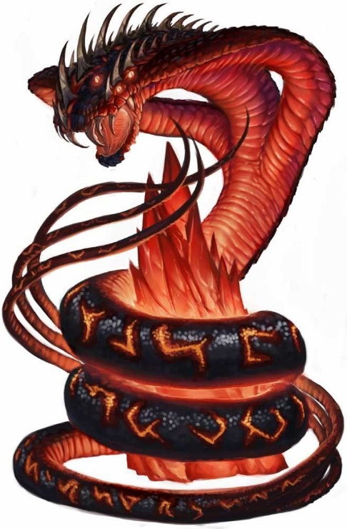*The Lava Bridge* – This room has a wide flow of lava with several glass/crystal columns (seemingly unaffected) rising out of it. The columns are connected by rail-thin bridges. To cross the room, you have to balance on the precarious walkways.

Unfortunately, the guardian of this room will appear soon after a character steps onto the thin bridges. A fire snake slithers out of the lava and crawls up the columns attacking one of the PCs. It will bite, or try to knock someone into the lava each round.

Of course, Vaara might be able to talk with the creature and secure passage… but what would such a being want?

*The Spirit Door* – Once through the lava flow, the characters will come to the entrance to the dungeon. A large, iron door with a life-like carving of a face and the word “IMMOLATE” (in shadow speak/old elven) etched above.

The door is very warm, but when disturbed, it will awaken and say, “Pardon me!” The door is well-mannered and will even offer some information if the PCs ask. However, the door has no idea how to open itself, or what is written on it.

To open the door, you have to get it to say IMMOLATE.

Information the door may have:

|  |  |
| --- | --- |
| Who are you? | I am a door. That seems obvious, doesn’t it? Well, OK. Perhaps I am being a little obtuse. Technically, I am a SPIRIT housed in a door. Put here by the master elven mage, Parmenides. |
| Contract | To free me. I was to guard the chambers beyond for 1000 years. I have fulfilled my end of the bargain, and it is past time I be freed. Unfortunately, without Parmenides, or the contract in question, I fear I am stuck here. |
| Dead | Yes, I can feel it. When he bound me to this door, we became bound. When he died, I felt it immediately. Shame, too… I had hoped he would have lived long enough to complete our contract. |
| Parmenides | Yes, yes… brilliant fire mage, and a nice enough fellow, as fire mages go (often as not, their tempers match their fiery spells). Dead unfortunately… |
| Trials? | Oh yes! Parmenides was fond of riddles. Bit of an intellectual snob, if I might say so. I mean, he is dead, so I suppose there is no harm. |
| What lies beyond? | The chamber of Igni, Song of Fire and the Trials of Parmenides. |

*The Hammer and The Anvil* – There is a statue of a blacksmith wielding a hammer over an anvil. There are some old bones here, and the remains of a long-dead fire, now just charcoal and ash.

The door on the left is firmly closed and only can be opened with a key. Whatever the adventurers draw with charcoal on top of the anvil it will magically be created made of stone. The only way to open the door is to draw a key in the anvil.

*Volcanic Spawn* – A simple room with some mooks to fight to break up the puzzle bits

*Unity Trap* – The floor of this room is warm – almost uncomfortably so. There is a small hole in the ground where only one of them can fit and avoid the spikes. As soon as the adventurers enter in this room the spiked ceiling will start to go down and the doors will lock.

The room is empty, other than the spikes and the hole. However, in the frantic search that is sure to start, characters might notice inscriptions above both doors that say “UNITY”.

The trick is that the ceiling will stop before crushing the adventurers while the one in the hole will fall into a pit trap.

*The Reliquary of Igni* – Igni is here, housed in a crystal case, suspended above a pool of lava by a set of chains. No tricks here… but someone is going to have to get to the scroll and open the case. Once they do so, they will here a voice telling them as long as they hold the scroll, they are immune to fire…

***Gripol***

* Gripol is an enclave of former slaves, like the PCs
* They are in a similar situation, but less of them survived because the shadows managed to kill more of them in the final battle (they have only 1 unit), including most of the leader/hero types
* Their leader is Nienke and she is a skilled logger and carpenter
* Also knows Glassblowing and how to find sources of sand

***Parga***

* Parga is a group of three tribes who live in the outdoor portion of their former shadow stronghold
* There are three groups living here, none of which get along particularly well
  + Theyd – led by Kester
  + Dwarves – led by Albok
  + Humans – led by Cynna
* Each is looking for a way to gain advantage over the other two and expel them, or rule over them
* In the meantime, their lack of cooperation has led to them having built, or researched nothing. They are barely hanging on the brink of crisis
* They are currently deadlocked, but the arrival of Rigut (and soon the PCs) will change that, as each group tries to use the outsiders to gain support/advantage

***Rigut –The Raider Enclave***

* Players encounter the raider enclave of Rigut for the first time
* This is a freemen enclave with 2 units of raiders and 1 unit of slaves (200-250 people in total)
* They have the techs
  + Military training
  + History
  + Locks/nets (tools of slavery)
  + Currency (freemen all have this)
    - They use Bronze Bits as currency
  + Leatherworking
* They live in the remains of an old human settlement, with a rampart, ditch and spikes defending it, along with the remainder of the original wall
* Their leader is Alaric The Fist
  + He is a giant of a man
  + Legend has it, he found a potion that made him so large
  + He is a high level pugilist who beats foes to death with his hands
* One lieutenant is Geordina
  + She is a reasonably skilled fire mage
* Their ultimate goal is to create a permanent situation in this region with the locals all paying tribute/tax for their “protection”
  + They are sending diplomats to the enclaves to that effect
    - The enclave will be asked to pay 4 resources each year to Rigut in exchange for safety (this is pretty steep)
    - They will likely take 3 (or 2??) on a successful negotiation
    - I don’t expect the PCs to go for this
  + They will support the humans of Gripol against the others to further their agenda
* Is there another enclave not yet on the map?